Topic: using books with learners in prisons
Level: Entry level 1 - 3 / National 2 – 4 / CEFR A1 - B1
Time: 155 minutes plus extensions. You could split the lesson over more than one session.
Aims
- To develop students’ ability in reading.
- To encourage reading for pleasure.
Objectives
Learners will be able to:
- understand vocabulary relating to books
- understand how to improve their reading skills
- talk about their thoughts about books
- plan and write a simple book reviews.
Introduction
This lesson includes a variety of activities to use with your ESOL learners in prison to encourage reading for pleasure, begin to critically examine texts, and develop an interest in books. It provides students with a range of tasks to develop reading, writing and speaking and listening skills related to books and vocabulary related to literature.

Contexualise the activities to the books you have available and adjust and adapt the levels to match individual learners. Suggestions for differentiation are included in the lesson plan. The activities extend skills in structuring writing, as well as promoting reading for enjoyment and beginning to critically examine texts.

This lesson relates to 2 other Offender Learning lesson plans: Using the prison library and the Six Book Challenge. We recommend using this lesson after having used those.

Before the lesson, get learners to choose books and have them in the class.

Preparation
You will need:
- Resource 1: 1 copy to display to the class
- Resource 2: low level – Version A and higher level – Version B. 1 cut up set per pair of learners
- Resource 3: 1 copy per pair of learners. Choose which cards to use according to level of learners
- Resource 4: low level – Version A and higher level – Version B. 1 copy per learner
- Resource 5: 1 copy per group of learners
- Resource 6: 1 per learner
- a range of reading material to show learners; include audio books and graphic novels if available and ask learners to bring a book from the library if possible.
- blank cards for learners to create their own flash cards
Procedure
Warmer (10 minutes)
- Display resource 1, put learners into small groups and ask them to discuss what they see in the picture and what they think about them.
- Separate the board into two sections. Nominate learners to feedback and write thoughts and feelings on one side and relevant vocabulary on the other side.

Activity 1: Pre teach book vocabulary (20 minutes)
- Put learners into groups according to level. Hold up and say one of the words from resource 2 and elicit a possible definition.
- Give learners a set of word/ definition cards (resource 2) to match.
- Tell learners to place the cards face down on the table then turn over two cards to make a pair with the word and its definition.
Differentiation/ extension
- Use version A with low level and version B with higher level learners.
- Card game: learners place word cards face down, turn them over, read them then give the definition. They can check after they have used all cards.

Activity 3: Speaking – preparing to read your book (20 minutes)
- Hold up the range of reading materials you have brought and elicit what they are e.g. books, magazines, newspapers, children’s books, posters, information sheets, etc.
- Elicit possible questions to ask about reading for example: ‘What do you read? Do you like reading? Why do you like reading? What language do you read in? Do you use the library?’
- Write prompts on the board like this:
  - what/ read
  - like/ reading?
  - why/ like/ reading?
  - what/ language?
  - library?
- Put learners in pairs and ask them to interview each other and make notes of their partner’s answers.
- Monitor learners while they are speaking and note any common mistakes to e.g.. word order for questions.
- Put pairs together with another pair and ask them to explain their first partner’s answers to their new partners.
- Feedback common errors: write on the board and elicit correct answer.
Differentiation/ extension
- You could add other questions if learners enjoy this activity such as: ‘How do you choose a book? Do you look at the title, author, cover, blurb, take a recommendation? Who helps you choose? Teacher/ librarian or friends? Do you look at the design on the cover? the size of print? Choose by author?’ (perhaps learners have read other books by the same author)?

Activity 4: Choosing a book– Exploring your chosen book (15 minutes)
- Write the following questions on the whiteboard.
- What is the title of the book?
- Who wrote the book?
- Where can you out about the book?
- Are there chapters in the book? Why/ why not?
- What does the cover tell you about the story?
- Ask pairs to answer the questions about their books with their partners.
Differentiation/ extension
- Learners can write the answers to the questions.
Activity 5: Before you start your book – previewing and predicting (15 minutes) It is useful to generate interest in the book and begin to get the learner thinking before they start reading.
- Elicit what you can do to work out what the book might be about e.g. look at the contents, the cover, the blurb to predict what the book might be about.
- Display one of the cards from resource 3 and ask learners to find the answer from the books they have in front of them.
- Depending on the level of the learners, give them some or all of the cards from resource 3 and ask them to find the answers.
- You may need to demonstrate how to skim read: with resource 3 on the board, ask learners to find the word past. With your finger, demonstrate moving quickly over the document until you find the word.
- Nominate learners to tell you what they found out.
Differentiation/ extension
- Lower-level learners: select cards from resource 3 according to the level of the learner.
- Higher-level learners: ask learners to pick out 4/ 5 sentences from various parts of the book that help give clues about the story and characters.
Activity 6: Reading the book – paired reading (15 minutes)
Paired reading develops fluent reading. It is a useful strategy to help students develop literacy skills, but needs to be enjoyable so be careful what and how much you ask learners to read and who you ask them to work with.
- Depending on the level of the book they are reading, pair learners either by similar ability together or pair stronger with weaker readers.
- Learners take turns in reading a sentence, paragraph or page each. While one learner is reading the other learner follows the text.
- Encourage learners to question each other about the reading. They should also help each other with pronunciation and unfamiliar words/ spellings.
- Encourage your learners to re-read difficult passages after they have negotiated meanings and difficult pronunciation.
Differentiation/ extension
- Learners can also read simultaneously. Get them to discuss and agree the pace so they can stick together. This can be a useful technique to help weaker readers.
- Allow learners to use dictionaries, but sparingly: only when they need to understand the sentence.
- Readers can keep a reading record as a way to show their progress in reading and to help them reflect.
Activity 6 alternative method: Reading the book – reading as a class
- Ask learners to read a page or a chapter of a book together in the class. Learners should take turns reading as much or as little as they can manage.
- When listening, they should follow the text.
- Stop and ask questions to check understanding at regular intervals.
- At the end get the learners to retell what they read: elicit events, details such as a word, name.
Differentiation/ extension
- Put learners in teams of 3 or 4. Ask them to discuss the story and agree how to retell it. They can make notes if they like. The winner is the group which tells the story in the most accurate way using appropriate language e.g. adjectives, etc.
- Ask them to predict what happens next. Ask if their view of the characters has changed. They can then check whether they were right or not?
Activity 7: Writing – keeping a record of reading (10 minutes)
It is useful for learners to record their thoughts and feelings about books so they realise, for example, what genre they like. It will also help them to start to become critical: this will help them for future learning i.e. preparing them for Functional Skills or GCSE.
- Display resource 4 Version A (Beginner/ E1/N2 reading record) and elicit what goes next to each section.
- Give learners a copy and support them to fill it in.
Differentiation
Higher level learners: use Version B.
Activity 8: Writing – summarising stories or shorter and shorter (20 minutes)
- Group learners with others of the same level and ask then to pick out key words from the story.
- To familiarise these words ask learners to make their own flash cards or matching game.
- Learners could then write of stick words in vocabulary books.
- Using the words help learners build a sentence based on these headings:
  - the story
  - a character(s)
  - what they liked about the story
  - what they liked / didn’t like about the character

Differentiation/ extension
- Work with learners who have had the story read to them.
- Ask higher-level learners to write a summary of the story using these headings: plot; characters; main events; what they liked/didn’t like about the story.
- Set the length of this according to the ability of your learners – one or two paragraphs/ one page of writing.
- Next ask learners to make this summary shorter then shorter again. This creates a challenge to write concisely without losing detail.
- Learners can make a poster to display for the classroom wall.

Activity 9: Writing – book review five ‘w’ questions (and 1 ‘h’!) (20 minutes)
- Give learners a set of resource 5 cards to place face down.
- Pairs or small groups of learners work together. The task is to talk about the books they read: learners turn a card over one at a time and say something and others should ask a question.
- Use resource 6 (writing frame) to write a book review: display the framework and elicit what learners should write.
- Write some examples then give a copy to learners and ask them to complete.
Differentiation/ extension
- Higher-level learners: ask them to think of 5 questions about the book they have read to ask another learner.
- If they are working with someone who has read the same book they can discuss it.
- Lower-level learners: assist learners to complete the writing frame. If learners have read the same book, pair them to use the writing frame.

Cooler (10 minutes)
- Divide the group into two mixed level teams. Teams take it in turn to say one fact about today’s lesson, for example, something they have found out about the stories or the author; the spelling of a word they have learned.
- Teams earn 1 point for the idea and extra points for correct spellings, grammar, etc.
Extension activities
- Design a poster to advertise a book you enjoyed.
- Write a postcard:
- to a friend to tell them about the book
- to the author to say what you liked did or didn’t like about the book.
- Write 10 words to describe the book.
- Make a story board either using pictures or frames for main events.
- Write a short newspaper article about something that happened in the story.
- Celebrate all learners reading efforts by making a reading banner around the room with learners’ contributions from the above activities/ storyboards/ postcards/ posters.

Resource 1
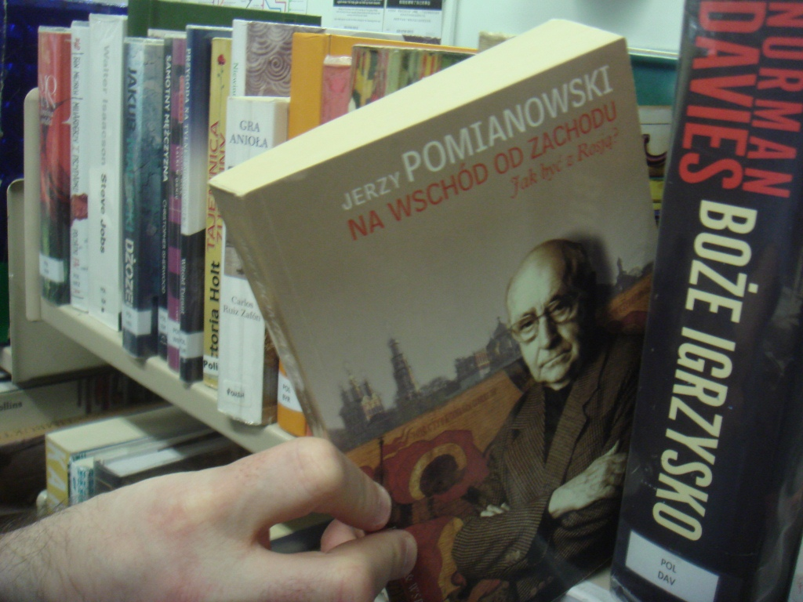
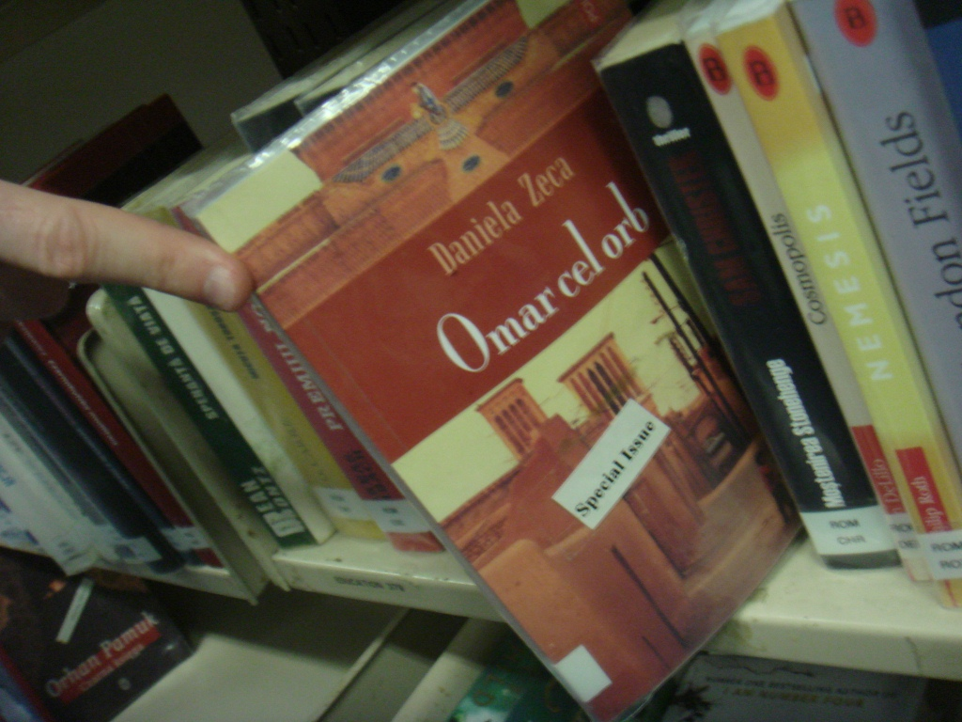

Resource 2

Version A
blurb | a short text telling you about a book
pages | paper sheets in a book
title | the name of the book or story
author | writer of the book
story | write about what happened for people to read
chapter | a part of a book

Version B
author | writer of a book
characters | the important people in the story
title | the name of the book or story
review | a report saying what you think about a book
fiction | a story that is made up
recommendation | telling someone they would like a book
non fiction | a factual book; true or information
chapter | a part of a book
blurb | a short text describing a book

Resource 3
Look at the book cover.  What’s the story about? | Read the blurb.  What’s the story about? | Look quickly through the book. What are the names of the people in the book?  What do you think they will be like?
Look quickly through the book.  Are there chapters?  How many chapters are there? | Look quickly through the book.  Can you find the names of places?  Where does the story take place | Look quickly through the book.  Do you think the story takes place in the past, present or future?
What’s the title of the book? | Who wrote it? | Do you know anyone who has read the book? Did they enjoy it?

Resource 4: Reading record

Version A
Reading record

My name:
Date:
What I read today:
How good was it?
How well did I do?

Version B
Reading record

My name :
Date:
Title:
Author:
Names of the main characters:
What I read about today:

Resource 5
Who? | When?
What? | Where?
Why? | How?

Resource 6 My book review
The title of the book/ story I read is_______________________________________

The author is _______________________________________________________
Introduction: what is the book about?

Who were the characters?

What happened in the story?

What else/

Was it funny? Sad? Scary?
What did you think about the book? Did you like it? Say why or why not?

Would you recommend it to a friend? Say why

